A story about Tom and his sister

One Sunday morning, Tom was watching a football match on TV
excitedly at home.
Tom’s sister walked into the room. She said, ‘ I want to watch
the music show.’ Tom replied, ‘But I want to watch the football match.’
His sister felt upset. Tom was unhappy.
Suddenly, Tom’s sister snatched the remote control from her
brother. She quarrelled with him. His sister shouted, ’You should give
me the remote control. I want to watch the music show. Tom cried
loudly, ‘ I will not give it to you. I want to watch my favourite football
match.’ They felt unhappy.
In the end, they broke the remote control. They felt so angry.
They fought with each other.
It was a sad ending because they could not watch TV anymore!
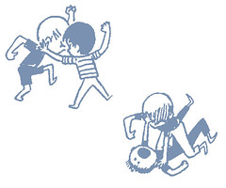
5S Ophelia Tong

